IMPLEMENT A BASIC REINFORCEMENT LEARNING MODEL (Q- LEARNING)

AIM
To implement the Q-Learning Reinforcement Learning Algorithm using Python to learn the optimal path to a goal state using a predefined rewards matrix and display the resulting Q-table.

ALGORITHM
- Import the NumPy library.
- Define the rewards matrix R, where each element represents the reward for moving from one state to another.
- Initialize the Q-table with zeros using np.zeros_like(R).
- Set the discount factor gamma to 0.8 and the number of training episodes to 1000.
- Randomly select an initial state for each episode.
- Identify all valid actions from the current state using the rewards matrix.
- Randomly select one valid action and determine the next state.
- Update the Q-value using the Q-Learning update rule:

Q(s,a)=R(s,a)+γmax⁡a′Q(s′,a′)Q(s,a)=R(s,a)+γa′max​Q(s′,a′)

- Repeat the process until the goal state (state 5) is reached.
- Display the final Q-table.

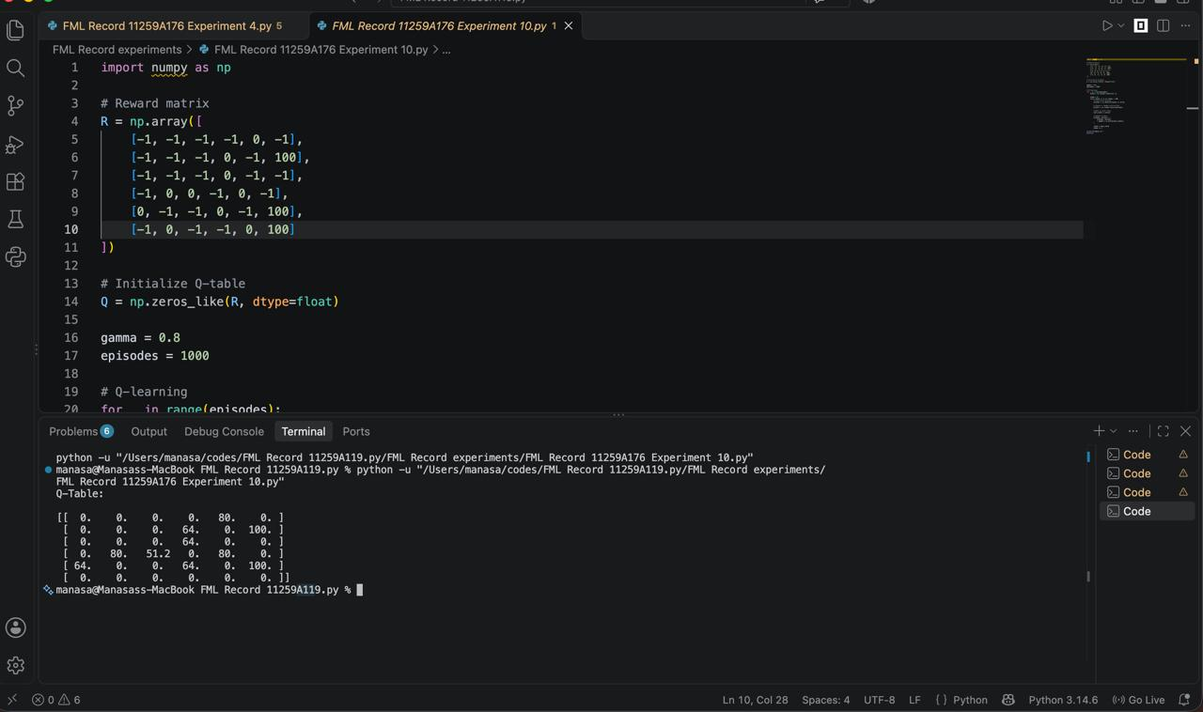

RESULT
Thus, the Q-Learning algorithm was implemented successfully. The Q-table was updated over 1000 episodes to learn the expected rewards for valid state transitions and identify paths toward the goal state.

